|  |
| --- |
| Artificial order |
| Incoming |
| External Game Document |
| External Game Document  Version Beta  All work Copyright © 2019 by Artificial Order.  All rights reserved. |
| **Peitong Liu** |
|  |

|  |
| --- |
| Oct 8th 2019 |

1. **Game Overview**

*The game goal is to avoid the enemies attacking the earth and make sure the health level does not drop down to 0.*

1. **Game Play Mechanics**

*The game mechanics is to avoid two different types of enemy and collect power ups to gain points.*

1. **Camera**

*2D side.*

1. **Controls**

*W/up to go up, S/down to go down.*

1. **Saving and Loading**

*There is no saving and loading system for there is only one level.*

1. **Interface Sketch**

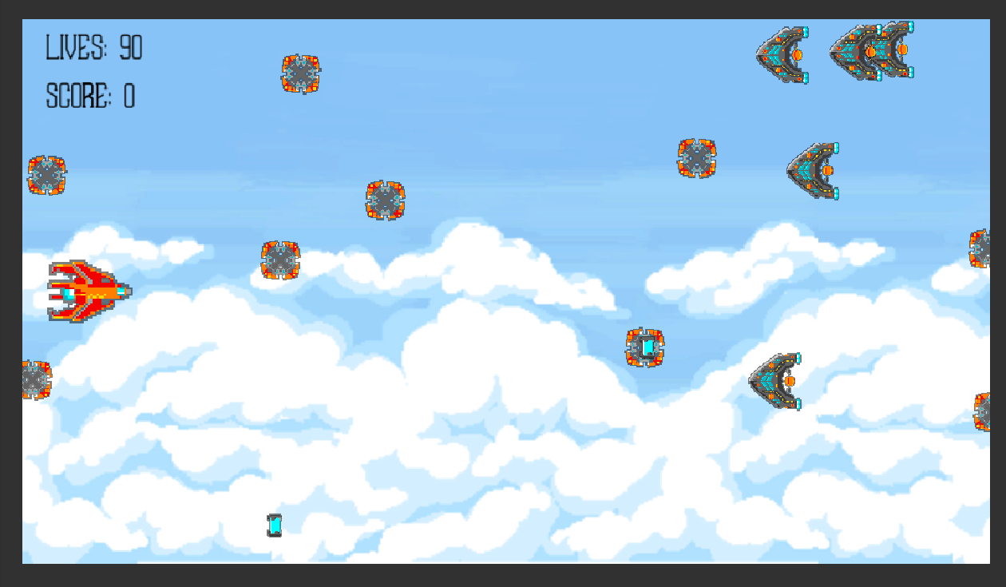

1. **Menu and Screen Descriptions**

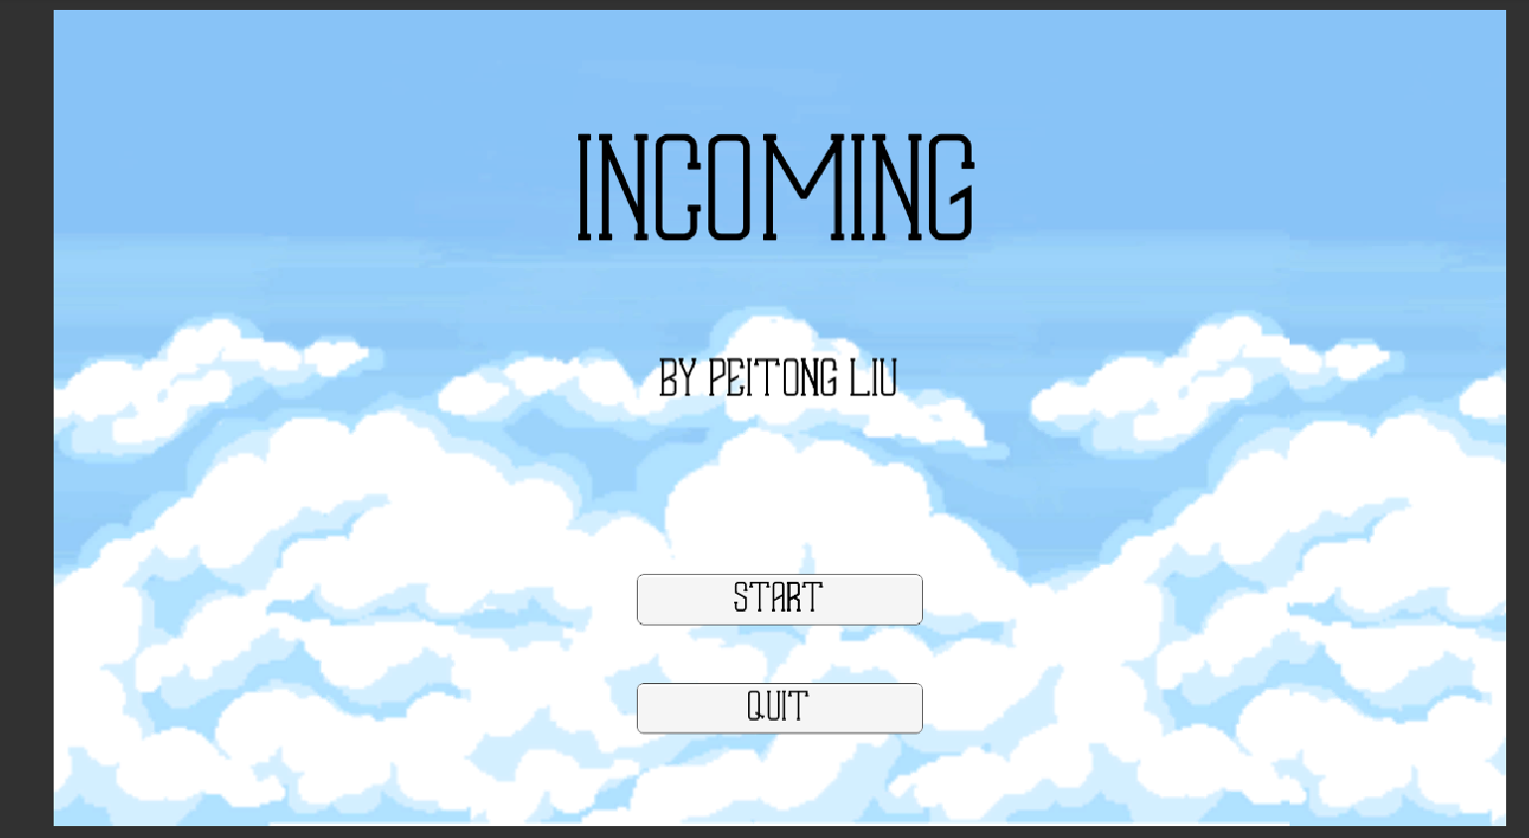

1. **Script**

*The game uses Unity engine and C# scripts, there are scripts for background scrolling, player control, enemy generation and movement, and each scene has a separate controlling script for buttons and UI elements.*

1. **Scoring**

*The score is gained by collecting power ups, the score is stored by a PlayerPref class and displays on the game over scene.*

1. **GitHub Repository**

[*https://github.com/V1ncentLiu/COMP305-Assign01*](https://github.com/V1ncentLiu/COMP305-Assign01)

*All the elements in the game, including sound effects, fonts and background:*

*Background: Sky background*

*Origin: https://opengameart.org/content/sky-background*

*Character: Simple Spaceships*

*Origin: https://assetstore.unity.com/packages/2d/textures-materials/simple-spaceships-81051*

*Enemies: Simple Spaceships*

*Origin: https://assetstore.unity.com/packages/2d/textures-materials/simple-spaceships-81051*

*Fonts: EVALIA*

*Origin: https://www.1001fonts.com/evalia-font.html*

*SFX: (Multiple)*

*Origin: https://www.zapsplat.com*